**FPT ACADEMY INTERNATIONAL**



## FPT – APTECH COMPUTER EDUCATION

**INCREDIBLE BRIDGES**

|  |  |  |  |
| --- | --- | --- | --- |
| **Center Name** | | FPT – Aptech – HCM1  Address: 391A Nam Ky Khoi Nghia, District 3, Ho Chi Minh City | |
| **Instructor** |  | Ms. Le Mong Thuy |  |
| **Class** |  | T1.2210.M0 |  |
| **Group** |  | 2 |  |
| **Group members** | | **Name** | **Student ID** |
|  |  | Do Ngoc Duy | Student1429829 |
|  |  | Tran Thi Diem Quynh | Student1429093 |
|  |  | Nguyen Dinh Hoai Nghia | Student1429114 |
| **Duration** | Start date | 01th Feb 2023 |  |
| End date | 03th Mar 2023 |  |

**This is to certify that**

**Mr. / Ms.:**

Do Ngoc Duy

Tran Thi Diem Quynh

Nguyen Dinh Hoai Nghia

**has successfully designed & developed**

eProject:Incredible Bridges.com website

**Submitted by:**

Do Ngoc Duy

**Date of issue:**

**Authorized Signature:**

**TABLE OF CONTENTS**

****FPT – APTECH COMPUTER EDUCATION 1****

****TABLE OF CONTENTS**** ****2****

****ACKNOWLEGMENT**** ****3****

****SYNOSIS**** ****3****

****PROBLEM DEFINITION**** ****3****

****CUSTOMER'S REQUIREMENTS SPECIFICATIONS (CRS) 4****

****Business/Project Objective**** ****4****

****Hardware/ Software Requirements**** ****5****

****SCOPE OF THE WORK (IN BRIEF) 6****

****Architecture and design of the system 7****

****Diagram of the website 8****

****TASK SHEET REVIEW 1 9****

****SITE MAP 10****

****MOCK OF THE WEBSITE 1********1****

***1. Homepage 1******1***

***2. Product 1******2***

***3. Blog 1******3***

***4. About Us 1******4***

***5. Contact US 1******5***

***6. Service 1******6***

***7. Sign In/ Sign Up 1******7***

****TASK SHEET REVIEW 2 18****

WEBSITE DESCRIPTION ****1********9****

RESPONSIVE****28****

[****JAVASCRIPT DESCRIPTION****](#Javascript) ****30****

****TASK SHEET REVIEW 3**** ****47****

# ACKNOWLEGMENT

This project consumed huge amount of work and dedication. Still, implementation would not have been possible if we did not have a support of many individuals. Therefore we would like to extend our sincere gratitude to all of them.

First of all we are thankful to Ms Le Mong Thuy for providing necessary guidance concerning projects implementation as well as her provision of expertise. Without her superior knowledge and experience, the Project could not have been successful. We also would like to express our sincere thanks towards the members of the team who devoted their time and knowledge in the implementation of this project.

Finally, we express our gratitude toward our families and colleagues for their kind co-operation and encouragement which help us in completion of this project.

# SYNOSIS

Incredible Bridges is a website which provides information about various famous bridges around the world.

Incredible Bridges offers users the opportunity to learn more about World Bridges. All of the information is well organized and put into categories so it is very easy to search for and not time-consuming.

Incredible Bridges also allows its users to share their ideas with other people who have the same interest or even with the admin. Moreover, usefull information about buses and fights to reach the places is provided as well.

# PROBLEM DEFINITION

The Web site is to be created based on the following requirements.

1) The Top of the Page should be presented with a suitable logo and various images of famous bridges.

2) Site should have sections as Historical Great Bridges, High-Level Achievements in Bridges, Iconic Bridges, and Modern Great Bridges etc.

- Various bridges should be listed in these sections accordingly

3)Sections like Longest, Tallest, Highest, Oldest etc. to be added to the website.

4)History and information of the bridges should be added along with the images.

5)The site must contain the filter based on Continents to look for various bridges in the continent

6)Gallery can be added for viewing different images.

7)Feedback must be allowed to enter by the viewer.

8)Site map, Gallery, About us, FAQ link, Contact us link must be added.

9)About Us and Contact Us: This menu option should display Email id, address, and contact number of the organization who is developing the system.

10)The advertise section of bus, flights can be included for reaching the places.

# CUSTOMER'S REQUIREMENTS SPECIFICATIONS (CRS)

**Client: Incredible Bridges**

### Business/Project Objective:

* Provide users interesting information about famous bridges around the world
* Allows users to search for their favorite bridges by its name
* Help users to identify brigdes location and find ways to reach there.

**Input to the system:**

* Feedback from visitor.

**Output from the system:**

* Detailed information about the bridges as well as illustrated pictures.
* Display location of the bridges and provide information about buses and flight to reach the places.
* Display a visitor count.

**Process**:

* + - * Validate data input from users.

**Expected delivery date:** 3-Feb-2023.

**List of deliverables:**

- Document Word, PDF.

- Source code.

### Hardware/ Software Requirements:

* **For developer**

**Hardware**

* + Intel Core i3/i5 Processor or higher
  + 8 GB RAM or above
  + Color SVGA
  + 500 GB Hard Disk space
  + Mouse
  + Keyboard

**Software**

Technologies to be used:

* + Frontend: HTML5, CSS, Bootstrap, JavaScript, jQuery, AngularJS.
  + Data Store: JSON files

Other Requirements:  
 • Operating Portal: Windows  
 • Browsers: Edge, Chrome, Mozilla Firefox, Safari,Coccoc

# SCOPE OF THE WORK (IN BRIEF)

After a long and detailed discussion, our group has decided to create a website contain the following webpages:

1. ***Home***: There is a menu bar to display 5 categories: Home, Information (Top Longest Bridges, Top Highest Bridges, Top Oldest Bridges, World Modern), Gallery, Contact us and FAQ.
2. Each Bridge webpage will show 3 bridges.
3. ***Gallery:*** Displays all picture of website.
4. ***Contact Us***: Display the address of the company, Map and allow customers to request  
   any information.
5. ***FAQ***: Display some common question and answer related to website and bridges.

# ARCHITECTURE AND DESIGN OF THE SYSTEM

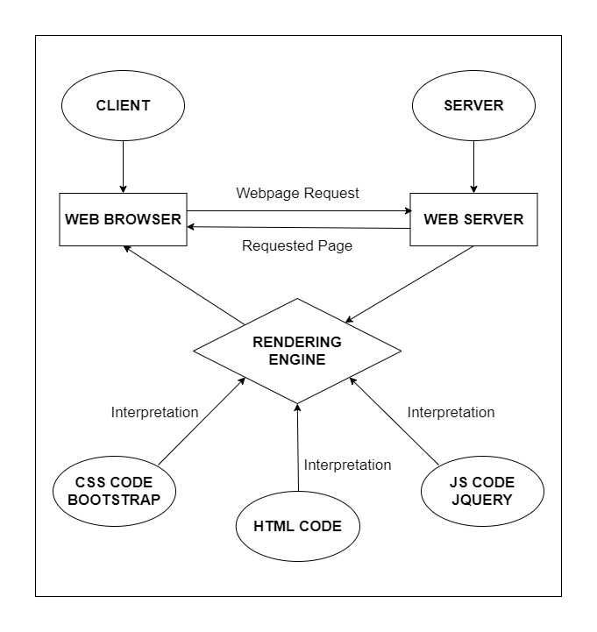

# DIAGRAM OF THE WEBSITE

**Begin**

**Home**

Top Longest Bridges

**Information**

Top Highest Bridges

Top Oldest Bridges

World Modern

**Gallery**

**Contact us**

**FAQ**



# TASK SHEET REVIEW 1

|  |  |  |  |  |  |  |  |
| --- | --- | --- | --- | --- | --- | --- | --- |
| **Project Ref. No.:**  **eP/Advertisement Portal Management**  **System/01** | | **Project Title:** | **Activity Plan Prepared By:** | **Date of Preparation of Activity Plan:** | | | |
| **Sr.**  **No.** | **Task** | **Actual**  **Start**  **Date** | **Actual Days** | **Team**  **Mate Names** | **Status** |
| 1 | Problem Statement | Incredible Bridges | Duy | 01-Feb-2023 | 1 | Duy | Completed |
| 2 | Analysis equirements about the website | 01-Feb-2023 | 1 | Nghia | Completed |
| 3 | The scope of the work (in brief) | 01-Feb-2023 | 1 | Nghia | Completed |
| 4 | Architecture and design of the system | 01-Feb-2023 | 1 | Quynh | Completed |
| 5 | Task Sheet | 01-Feb-2023 | 1 | Quynh | Completed |

|  |  |
| --- | --- |
| **Date:** | |
| Signature of Instructor:  **Ms. Le Mong Thuy** | Signature of Team Leader:  **Do Ngoc Duy** |

# SITE MAP

FAQ page

Developer infor & contact page

FAQ

Contact us

Detail bridges

Picture in different view

Gallery

Home

Information

Detail

Homepage

Word Modern

Top Oldest Bridges

Top Highest Bridges

Top Longest Bridges

# MOCK OF THE WEB SITE

1. **Homepage**

Footer

Site map

Advertise

Information

Slide Show

Logo

Menu bar

1. **Detail Bridges**

Menu bar

Logo

History

Information

Location

Footer

1. **Gallery**

Menu bar

Logo

Footer

Gallery picture

1. **Contact us**

Menu bar

Logo

Feed Back

Location company

Footer

Member information

1. **FAQ**

**Lo**

Menu bar

Logo

FAQ information

Footer

# TASK SHEET REVIEW 2

|  |  |  |  |  |  |  |  |
| --- | --- | --- | --- | --- | --- | --- | --- |
| **Project Ref. No.:**  **eP/Advertisement Portal Management**  **System/01** | | **Project Title:** | **Activity Plan Prepared By:** | **Date of Preparation of Activity Plan:** | | | |
| **Sr.**  **No.** | **Task** | **Actual**  **Start**  **Date** | **Actual Days** | **Team**  **Mate Names** | **Status** |
| 1 | Site Map | Incredible Bridges | Duy | 3-Feb-2023 | 1 | Quynh | Completed |
| 2 | Mock of the website | 3-Feb-2023 | 2 | Nghia | Completed |
| 3 | Task sheet | 3-Feb-2023 | 2 | Duy | Completed |

|  |  |
| --- | --- |
| **Date:** | |
| Signature of Instructor:  **Ms. Le Mong Thuy** | Signature of Team Leader:  **Do Ngoc Duy** |

DESCRIPTION:

- **Homepage** Display images of some of the top famous bridges and describe the return leg of their features. Accompanied by some advertising images will be displayed on this page

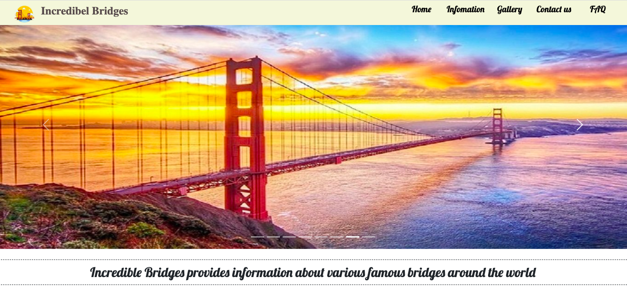

………………….……………………………………………………………………………………………………………..

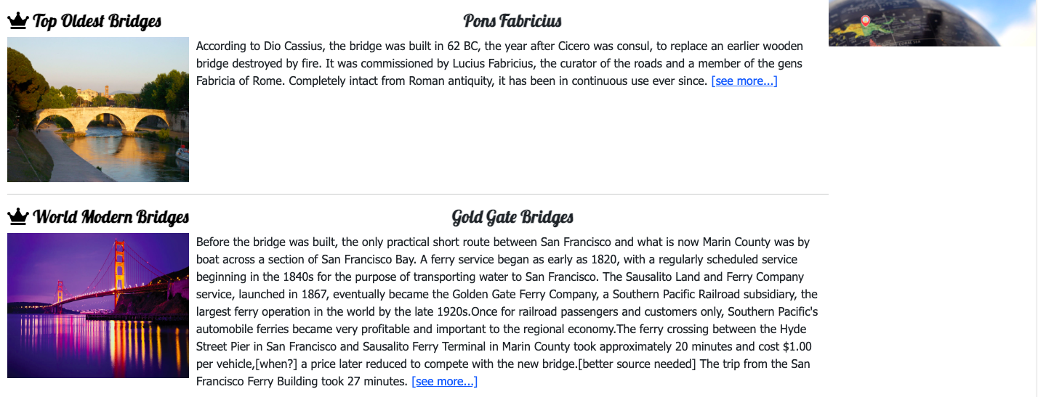

………………….……………………………………………………………………………………………………………..

GALLERY

INFORMATION:

- **Top Longest page** Briefly summarizes the longest bridges in the world. If users want to know more information of some specific bridges. They can click on the word "See More" next to the description. After that, it will tell us all the information about that bridge

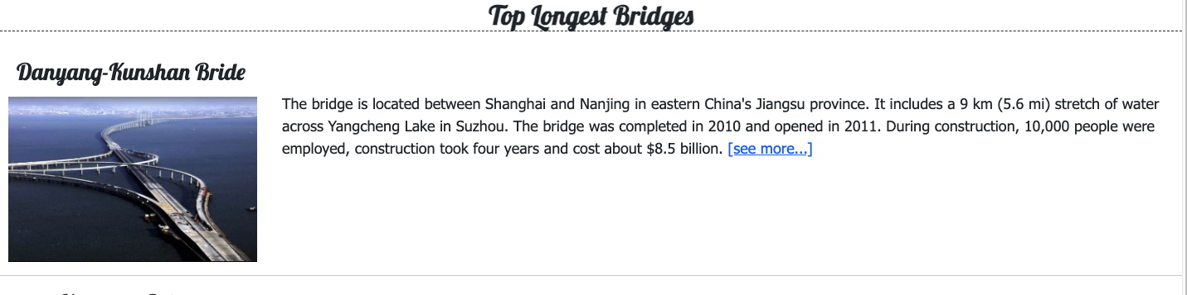

………………….……………………………………………………………………………………………………………..

- **Top Highest page** Briefly summarize the highest bridges in the world. If users want to know more information of some specific bridges. They can click on the word "See More" next to the description. After that, it will tell us all the information about that bridge.

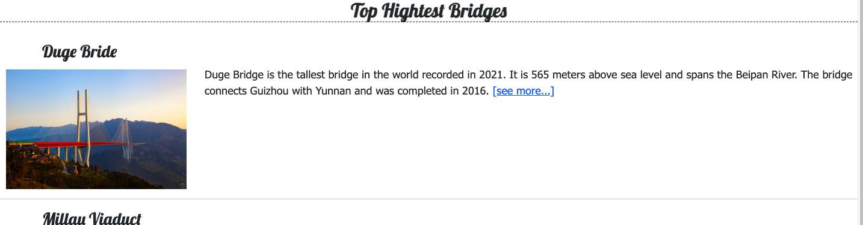

………………….……………………………………………………………………………………………………………..

- **Top Oldest page** Briefly summarize the oldest bridges in the world. If users want to know more information of some specific bridges. They can click on the word "See More" next to the description. After that, it will tell us all the information about that bridge

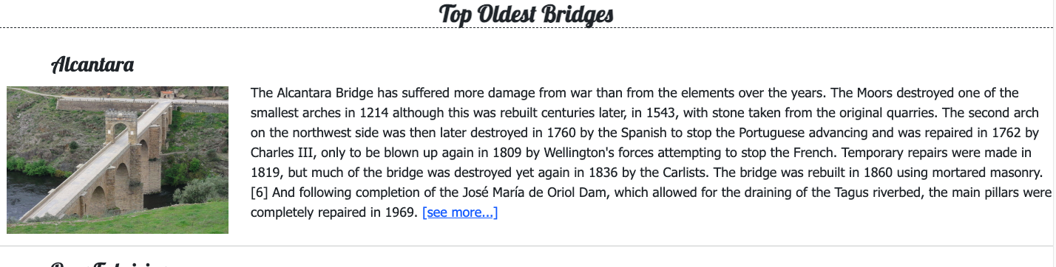

………………….……………………………………………………………………………………………………………..

- **Top modern bridges** Briefly summarizes the most modern bridges in the world. If users want to know more information of some specific bridges. They can click on the word "See More" next to the description. After that, it will tell us all the information about that bridge

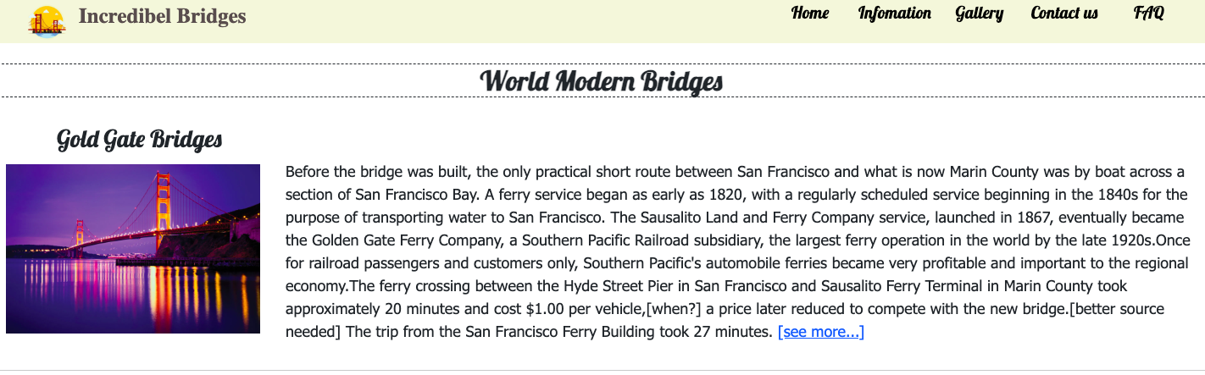

………………….……………………………………………………………………………………………………………..

- **Detail page** Fully describe the content and images of a specific bridge. Help users can find useful information can help them answer questions**.**

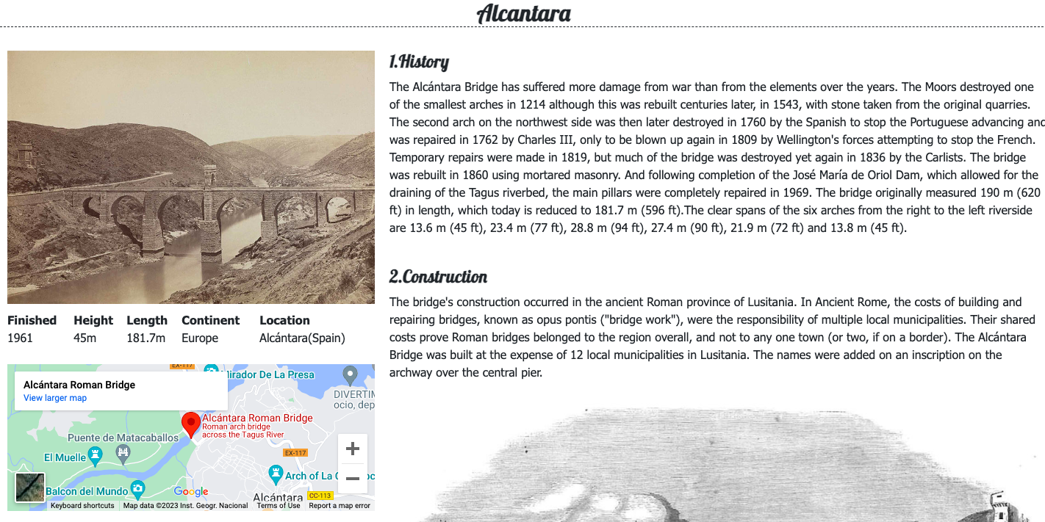

…………………………………………………………………………………….

CONTACT US:

-Show Feedback: Customers can contact Incredible Bridges via email on the page.

-Feedback: Customers can give feedback to Incredible Bridges aiming to contribute ideas to Incredible Bridges can improve better.

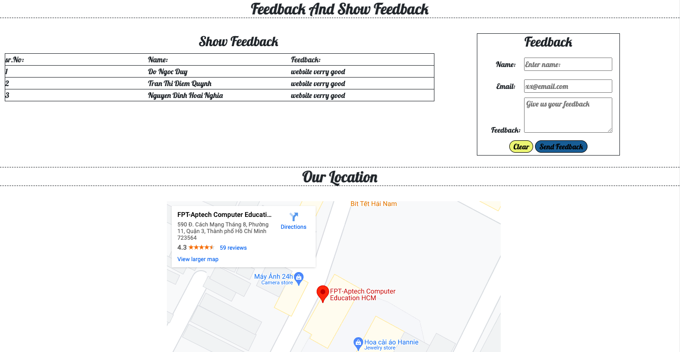

…………………………………………………………………………………………

- **FAQ** gives visitors some helpful hints about what they are looking for by providing common sample answers.

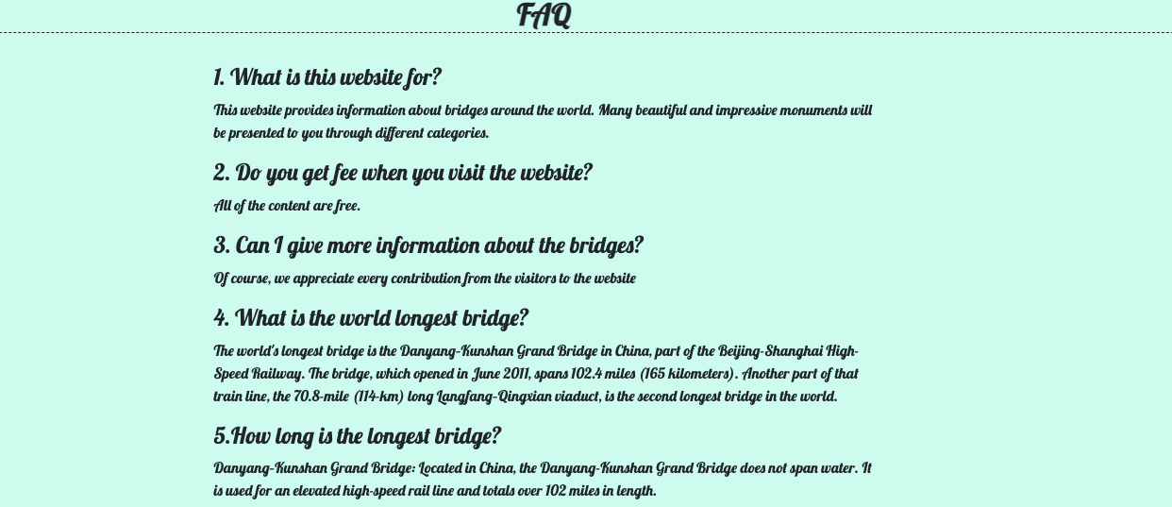

..………………………………………………………………………………………

HTML:

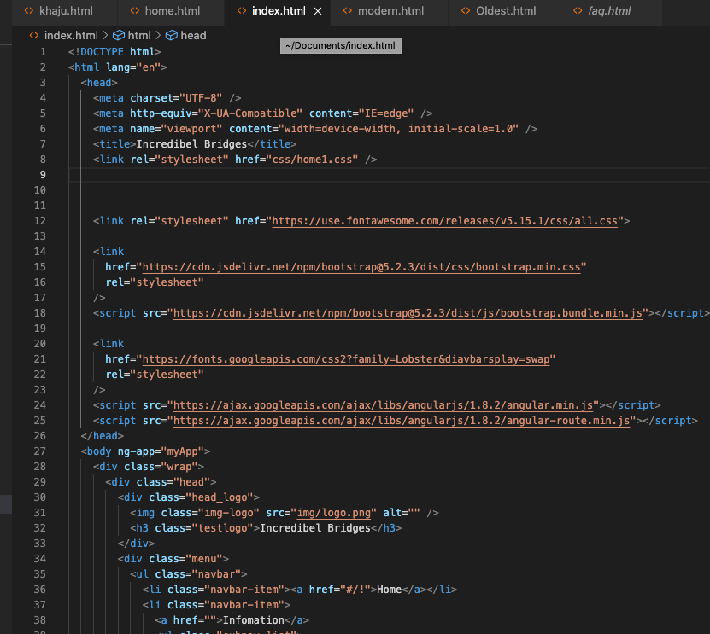

…………………………………………………………………………………

CSS :

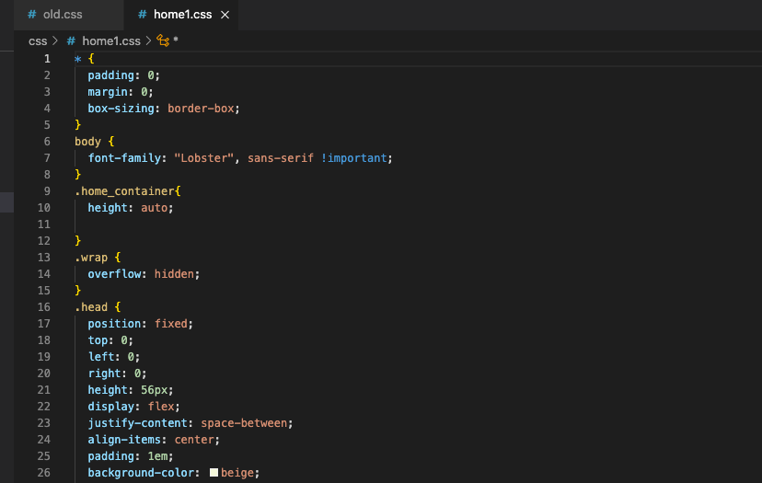

ANGULAR:

